Contents
Object Oriented Features 3
Object Oriented Programming Languages and Object based Programming Languages 3
Difference between Class and Object 3
Difference between Encapsulation and Abstraction 4
Inheritance 4
Polymorphism 4
Message Passing 5
Containers in Java or Topmost elements in Java 5
Class 5
Syntax 5
Access Modifiers 6
Procedure to use classes in Java Applications 9
Methods in Class, Abstract Class and Interface 12
Abstract Class 13
Procedure to use abstract classes in Java applications 14
Interface 16
Procedure to use Interfaces in Java applications 16
Method in Java 19
Syntax: 19
Method Signature and Method Description 22
Type of methods based on the Object state manipulations. 23
Variable-Argument Method 25
Syntax: 25
Ex: 25
Object Creation Process in Java 27
Syntax 27
Object Class 30
Types of Objects 34
Constructor 36
Syntax 37
Points to be Remembered 37
Types of Constructors 38
Default Constructor 38
User Defined Constructors 38
Constructor Overloading 40
Instance Context / Instance Flow of Execution 42
Instance Variables 42
Instance Method 42
Instance Block 42
This keyword 42
To Refer Current class Variables 43
To refer Current class methods by using this keyword 45
To refer current class constructors by using ‘this’ keyword 46
To return Current Class Object from the method 48
static keyword 51
Static Variables 51
Static Method 54
Static blocks 56
Static import 57
Static Context / Static Flow of execution 59
Class.forName() 63
newInstance() Method 65
Factory Method 67
Static Factory Method 68
Instance Factory Method 68
Singleton Classes 69
‘final’ Keyword 73
final variables 73
‘final’ Methods 74
‘final’ Classes 75
Enum 77

Object Oriented Features
To describe the nature of Object Orientation, Object Oriented programming languages have provided Object Oriented Features.
- Class
- Object
- Encapsulation
- Abstraction
- Inheritance
- Polymorphism
- Message Passing

Object Oriented Programming Languages and Object based Programming Languages
- Object Oriented programming languages are following almost all the Object-Oriented features including Inheritance.
- EX: Java
- Object Based Programming languages are following almost all the object-oriented features excluding Inheritance.
- EX: Java Script, SNOBOL

Difference between Class and Object
- A group of elements have common properties and common behaviours, here the group of elements is called a Class.
Among the group of elements, an individual element having physical properties and physical behaviours is called an Object.
- Class is virtual.
Object is real / physical.
- Class is the virtual encapsulation of the properties and behaviours.
Object is the physical encapsulation of the properties and behaviours.
- Class is Generalization.
Object is Specialization.
- Class is a blueprint for the objects.
Object is an instance of the class.
- Class is a Model for all the objects.
Object is an instance of the class.
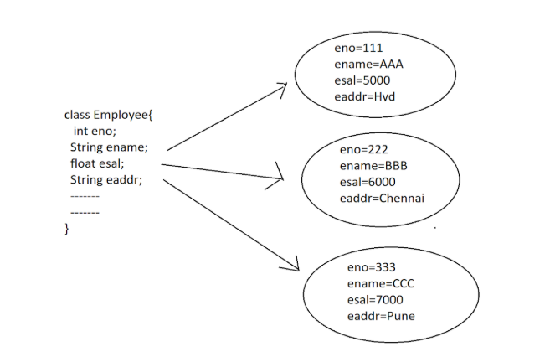

Difference between Encapsulation and Abstraction
- The process of Combining/Binding the data and coding part is called “Encapsulation”.
- The process of showing necessary implementation and hiding the unnecessary implementation is called “Abstraction”.
- Encapsulation + Abstraction = Security

Inheritance
- It is a relation between classes; it provides variables and methods from one class to another class to improve Code Reusability.
- The main Advantage of Inheritance is “Code Reusability”.

Polymorphism
- Polymorphism is a Greek word, where Poly means Many and Morphism means forms or Structures.
- If one exists in multiple forms, then it is called “Polymorphism”.
- The main advantage of Polymorphism is “Flexibility”.

Message Passing
- The process of transferring data from one class to another class along with flow of execution is called “Message Passing”.
- The main advantage of Message passing is to improve communication between classes, and data navigation.

Containers in Java or Topmost elements in Java
- Container is a Java element, it contains some other Java programming elements like variables, blocks, methods....
- In Java, there are three types of containers.
- Class
- Abstract Class
- Interface

Class
- Class is a container representing entities.
- EX: Student, Employee, Product, Account, .......

- Note: To represent entities data, we must use “Variables”.
- EX: accNo, accHolderName, accType,...
- Note: To represent entities behaviours / actions we must use “Methods”.
- EX: createAccount(), updateAccount(), searchAccount(), deleteAccount(),...

Syntax
[AccessModifiers] class ClassName [extends SuperClassName] [implements InterfaceList]{
—----Variables—-----
—----Methods—------
—----Constructors—-----
—----Blocks—--------
—----Enums—------
—----Classes—-----
—----Abstract Classes—---
—----Interfaces—-----
}
Observations from Class Syntax:
- Class syntax can allow only one super class.
- Class Syntax can allow any number of interfaces.
- In Class syntax, extends and implements keywords are optional
- First, we must write extends then we have to write implements, not possible to interchange order of extends and implements keywords.
- We can write classes, abstract classes, interfaces inside the
classes, inside the abstract classes and inside the interfaces.

Access Modifiers
- Access modifiers are used to provide scopes to the programming elements and to define some extra nature to the programming elements.
- There are two types of Access modifiers in java:

To define Scope to the programming elements we will use the Access modifiers like public, protected, <default>, private.
- Where “private” members will have scope up to the respective class.
- Where “<default> members will have scope up to the current package.
- Where “protected” members will have scope up to the current package and the child classes existed in the other packages.
- Where “public” members will have scope throughout the application
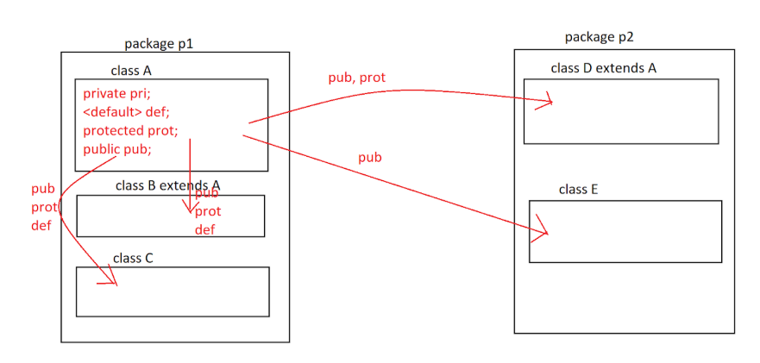
- Out of all the four types of scopes, only public and <default> scopes are applicable for classes, protected and private are not applicable for classes.
- Note: Inner classes can allow all four types of scopes like public, protected, <default> and private.
- Access modifier is applicable for the all the members of the class including inner classes.
Ex:
package nagoor.java.oops.p1;
public class A {
private double salary = 12345.55;
int age = 34;
protected String vehicle = "Audi";
public String name = "Appu";
}
class B extends A {
public void display() {
//Same package with inheritance
//Scope: Can access age[default], vehicle[protected],name[public]
//Access through: direct access no need to create Object
//Cannot access salary[private]
//System.out.println(salary); private cannot be accessed outside the class
System.out.println(age);
System.out.println(vehicle);
System.out.println(name);
}
}
class C {
public void display() {
//Same package without inheritance
//Scope: Can access age[default], vehicle[protected],name[public]
//Access through: Need to create Object
//Cannot access salary[private]
//System.out.println(salary); private cannot be accessed outside the class
A a=new A();
System.out.println(a.age);
System.out.println(a.vehicle);
System.out.println(a.name);
}
}

package nagoor.java.oops.p2;
import nagoor.java.oops.p1.A;
public class C extends A {
public void display(){
//Different package with inheritance
//Scope: Can access vehicle[protected],name[public]
//Access through: direct access no need to create Object
//Cannot access salary[private], age[default]
//Even import cannot access private and default members outside package
//System.out.println(salary); private outside class cannot be accessed
//System.out.println(age); default outside package cannot be accessed
System.out.println(vehicle);
System.out.println(name);
}
}
class D{
public void display(){
//Different package without inheritance
//Scope: Can access name[public]
//Access through: Need to create Object
//Cannot access salary[private], age[default], vehicle[protected]
//Even import cannot access private, default and protected members outside package
//System.out.println(salary); private outside class cannot be accessed
//System.out.println(age); default outside package cannot be accessed
//System.out.println(vehicle); protected outside package without inheritance cannot be accessed
A a=new A();
System.out.println(a.name);
}
}

To define some extra nature to the programming elements we will use the access modifiers like static, final, abstract, native, volatile, synchronized, transient, strictfp,.....

Container | Access Modifiers
Outer Class | final, abstract, strictfp || public, <default>
Members of Class | final, abstract, strictfp, static, native, volatile, synchronized, transient || public, <default>, protected, private

Procedure to use classes in Java Applications
- Declare a class by using the ‘class’ keyword.
- Declare variables and methods inside the class as per the requirement.
- Declare main class and main() method.
- Inside the main class, inside the main() method, create an object for the class.
- Access members of the class by using the generated reference variable.
Ex 1:
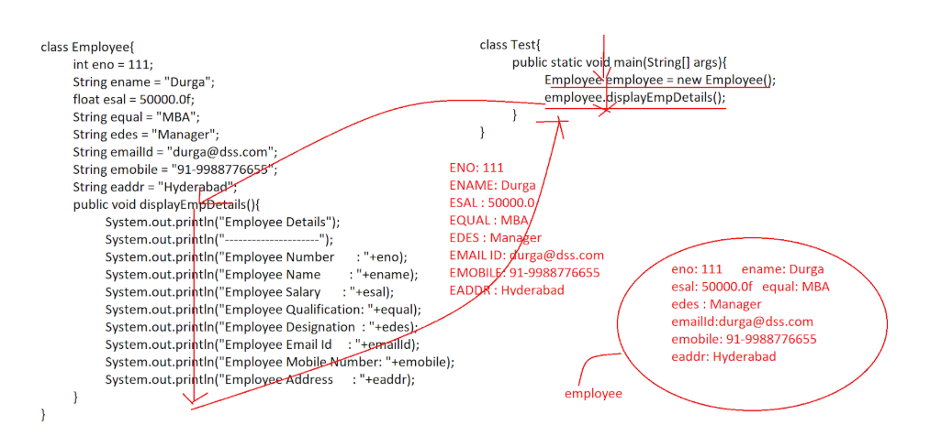
Ex 2:
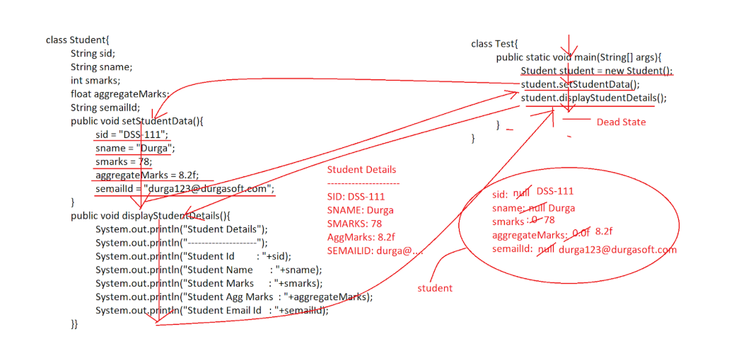
Ex 3:
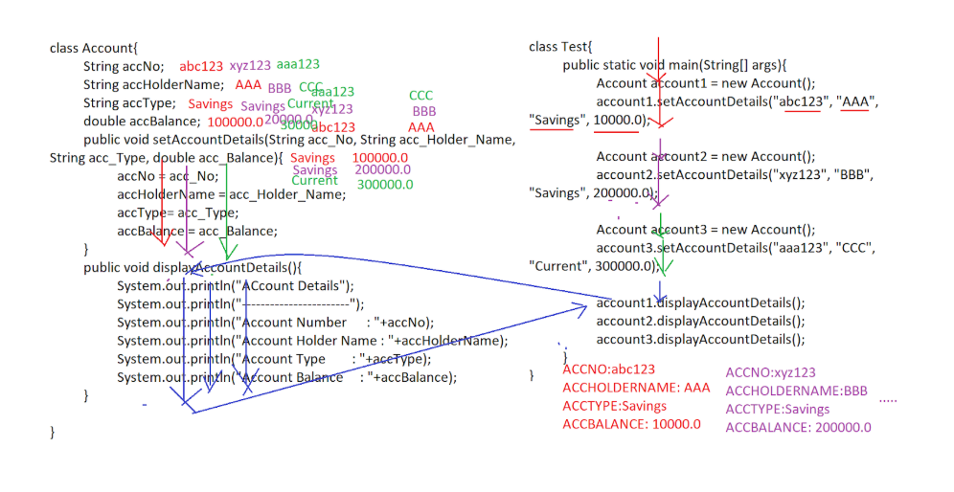
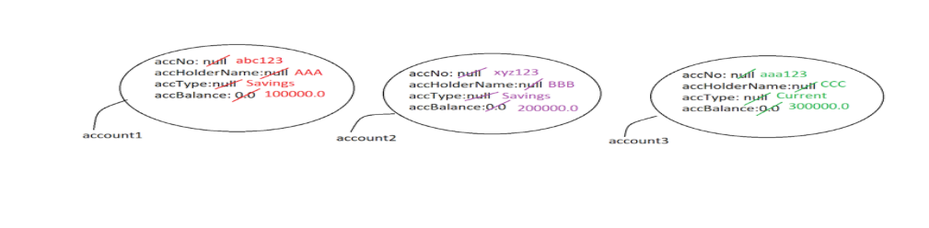
Ex 4:
package nagoor.java.oops;
class Employee {
public int id;
public String name;
public double salary;
public long mobile;
public void setData(int id, String name, double salary, long mobile) {
this.id = id;
this.name = name;
this.salary = salary;
this.mobile = mobile;
}
public void display() {
System.out.println("Employee ID: " + id);
System.out.println("Employee Name: " + name);
System.out.println("Employee Salary: " + salary);
System.out.println("Employee Mobile: " + mobile);
}
}
public class ClassDemo {
public static void main(String[] args) {
Employee e1 = new Employee();
e1.setData(100, "Appu", 234.55, 9916454100l);
e1.display();
System.out.println("*********************************************");
Employee e2 = new Employee();
e2.setData(101, "Raghu", 234.55, 9916454100l);
e2.display();
}
}
OUTPUT:
Employee ID: 100
Employee Name: Appu
Employee Salary: 234.55
Employee Mobile: 9916454100
*********************************************
Employee ID: 101
Employee Name: Raghu
Employee Salary: 234.55
Employee Mobile: 9916454100

Methods in Class, Abstract Class and Interface
In Java, there are two types of Methods
- Concrete Methods
- Abstract Methods

- Concrete Method is a Java method; it will have both method declarative part and method implementation part.
Abstract Method is a Java method; it will have only Method declarative part without the implementation part.
- To declare concrete methods no need to use a special keyword.
To declare abstract methods, we must use a special keyword like “abstract”.
- Concrete methods are possible in classes and abstract classes.
Abstract methods are possible in abstract classes and interfaces.
- Concrete Methods are able to provide less shareability.
Abstract methods are able to provide more shareability.

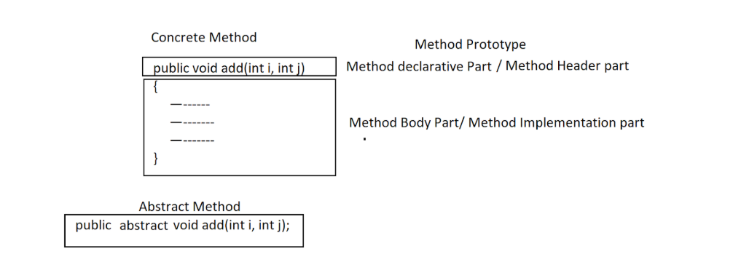

Abstract Class
- Abstract class is a Java class; it is able to allow both concrete methods[zero or more number] and abstract methods [zero or more number].
- We can write an abstract class without both concrete methods and abstract methods.
- In Java applications, for abstract classes we are able to declare reference variables only, we are unable to create objects.
- In Java applications, to declare an abstract class we have to use a special keyword that is “abstract” .

Note: If we declare any method or any class with “abstract” keyword then the compiler and JVM will understand that method and that class as an incomplete method and an incomplete class, for them we are unable to create objects.

Procedure to use abstract classes in Java applications
- Declare an abstract class with “abstract” keyword.
- Declare variables and methods inside the abstract class as per the application requirement.
- Declare a subclass for the abstract class.
- Provide implementations for all the abstract methods of the abstract class in the sub class.
- Declare main class, main() method.
- In the main class, in the main() method create an object for the sub class and declare a reference variable either for abstract class or for sub class.
- Access abstract class members.

Note: If we declare a reference variable for the abstract class [super class] then it is possible to access only abstract class members, not possible to access subclass own members. If we declare a reference variable for a subclass, then it is possible to access both abstract class [super class] members and subclass own members.
Ex:
abstract class Student{
int a=10;
public void m1(){
System.out.println("Abstract class method");
}
abstract public void m2();
}
class CSE extends Student{
@Override
public void m2() {
System.out.println("Abstract class implemented method");
}
public void m3(){
System.out.println("Implementation class own method");
}
}
public class AbstractClassDemo {
public static void main(String[] args) {
Student s=new CSE();
s.m1();
s.m2();
//s.m3(); Cannot access child class method
CSE c=new CSE();
c.m1();
c.m2();
c.m3();
}
}
OUTPUT:
Abstract class method
Abstract class implemented method
Abstract class method
Abstract class implemented method
Implementation class own method

Q) What are the differences between Concrete class [Normal Class] and abstract class?
- Concrete classes can allow only concrete methods.
Abstract classes can allow both Concrete methods and Abstract methods.
- To declare concrete classes, we must use the “class” keyword.
To declare abstract classes, we must use the “abstract” keyword along with “class” keyword.
- For the concrete classes we can provide both reference variables and objects.
For the abstract classes we can provide only reference variables, we are unable to create objects.
- Concrete classes can provide less shareability.
Abstract classes can provide more shareability.

Interface
- Interface is a Java feature, it can allow only abstract methods, not possible to have concrete methods.
- Note: From JAVA8 version onwards interfaces can have default methods and static methods with the implementation part.
- Note: From JAVA 9 version onwards, interfaces can have private methods with the implementation.

- To declare interfaces, we will use a separate keyword that is “interface”.
- For the interfaces we can create reference variables only, we are unable to create objects.
- Inside the interfaces, by default all variables are “public static final”, not required to declare explicitly.
- Inside the interfaces, by default all methods are “public and abstract”, not required to declare explicitly.
- Note: If we declare reference variables for the interface then we are able to access only interface members, we are unable to access implementation class own members, If we declare reference variables to the implementation class then we can access both interface members and implementation class own members.

Procedure to use Interfaces in Java applications
- Declare an interface with the “interface” keyword.
- Declare variables and methods inside the interface as per the application requirement.
- Declare an implementation class for the interface.
- Provide implementations for all the abstract methods of the interface inside the implementation class.
- Declare Main class and main() method.
- Create objects for the implementation class and declare reference variables either for the interface or for the implementation class.
- Access interface members.
Ex:
package nagoor.java.oops;
interface A {
int x = 10; //public static final
void m1(); //public abstract
void m2(); //public abstract
}
class B implements A {
@Override
public void m1() {
System.out.println("m1 method of interface");
}
@Override
public void m2() {
System.out.println("m2 method of interface");
}
public void m3() {
System.out.println("m3 method of implementation class");
}
}
public class InterfaceDemo {
public static void main(String[] args) {
A a = new B();
a.m1();
a.m2();
//a.m3(); Cannot access method of imp class
B b = new B();
b.m1();
b.m2();
b.m3();
//Interface variable can be accesses through Interface name, Implementation Class name, Interface
//reference variable, Implementation Class reference variable
System.out.println(A.x);
System.out.println(B.x);
System.out.println(a.x);
System.out.println(b.x);
}
}
Output:
m1 method of interface
m2 method of interface
m1 method of interface
m2 method of interface
m3 method of implementation class
10
10
10
10

Q) What are the differences between classes, abstract classes and interfaces?
- To declare a class, we must use only the “class” keyword.
To declare an abstract class, we must use the “abstract” keyword along with “class” keyword.
To declare an interface, we must use the “interface” keyword.
- Classes can allow only concrete methods.
Abstract classes can allow both concrete methods and abstract methods.
Interfaces can allow only abstract methods.
- For classes, we can create both reference variables and objects.
For the abstract classes and interfaces, we can create only reference variables, we are unable to create objects.
- In the case of interfaces, by default all variables are “public static final”.
No default cases exist for the variables in the classes and abstract classes.
- In the case of interfaces, by default all methods are “public and abstract”.
No default cases exist for the methods in the classes and abstract classes.

- Classes can provide less shareability.
Abstract classes can provide middle level shareability.
Interfaces can provide more shareability.

Method in Java
- To represent entities' behaviours or actions we must use methods in the classes.

- Method is a set of instructions, which are representing a particular action of an entity.
- EX: Transaction is an entity, where in Transactions we can define the behaviors or actions like “deposit”, “withdraw”, “transferFunds”,....
- EX: Account is an entity, where in Account entity we can define the behaviors or actions like “createAccount”, searchAccount”, “updateAccount”, “deleteAccount”.
- To prepare Methods in Java applications we must use the following syntax.

Syntax:
[AccessModifiers] ReturnType methodName([ParamList])[throws ExceptionList]{
—------
—------
—------
[return Value;]
}
- All Java methods can allow the access modifiers like public, protected, <default> and private.
- From the above list of access modifiers only one access modifier we can provide in the methods, it is not possible to provide more than one access modifier.
- All Java methods can allow the access modifiers like static, final, abstract, native, synchronized and strictfp.
- From the above list of access modifiers, we can use more than one access modifier in the methods, but they must be in valid combination.
EX1: static final : valid
static final void m1(){
—----
}
EX2: static abstract : Invalid
static abstract void m1(){
—---
}
EX3: final abstract: Invalid
final abstract void m1(){
—----
}
- Where “ReturnType” is mandatory in Java methods, it represents the type of the data which the Java method wants to return as an output from the action which is represented in the form of the method.
- In Java applications, we can use all primitive data types [byte, short, int, long, float, double, boolean and char] , all user defined data types [ classes, abstract classes, interfaces, arrays, enums,....] and “void” as return types.
- Note: ‘void’ return type is representing “no Value to return” from the method.
- Where “methodName” is a name assigned to the method to access that method.
- Where “paramList” is a list of parameters to the method which are used to provide input data to the methods to perform the respective action.
- In Java methods, parameterList can allow all primitive data types and all user defined data types.
- In Java methods, throws keyword can be used to bypass the generated exception from the present method to the caller method to handle that exception.
- Where “return” keyword can be used to return a value from the method to the caller of the method as per the return type.
Ex:
void m1()throws ExceptionName{
void m2();
}
void m2()throws ExceptionName{
void m3();
}
void m3()throws ExceptionName{
—----Exception—---
}

Q) Find the valid syntaxes of the methods from the following list?
- public void m1(){ } —-----------------------> Valid
- public void m1(){ }; —-----------------------> Valid
- protected void m1(){ } —--------------------> Valid
- default void m1(){ } —-----------------------> Invalid
- void m1(){ } —-----------------------> Valid
- private void m1(){ } —-----------------------> Valid
- public protected void m1(){ } —-----------------------> Invalid
- static void m1(){ } —-----------------------> Valid
- final void m1(){ }—-----------------------> Valid
- native void m1(); —-----------------------> Valid
- abstract void m1();—-----------------------> Valid
- volatile void m1(){ } —-----------------------> invalid
- abstract void m1(){ }; —-----------------------> Invalid
- transient void m1(){ } —-----------------------> Invalid
- synchronized void m1(){ } —-----------------------> Valid
- strictfp void m1(){ } —-----------------------> Valid
- int m1(){ }; —-----------------------> Invalid
- float m1(){ return 0.0f; } —-----------------------> Valid
- long m1(){ return 0.0f; } —-----------------------> Invalid
- double m1(){ return 0.0f; } —-----------------------> Valid
- double m1(){ return 10; } —-----------------------> Valid
- String m1(){ return “abc”; } —-----------------------> Valid
- int[] m1(){ return new int[]{10,20,30}; } —-----------------> Valid
- void m1(int i, int j){ } —-----------------------> Valid
- void m1(void ){ } —-----------------------> Invalid
- void 9m1(){ } —-----------------------> Invalid
- void m1(String str){ } —-----------------------> valid
- void m1(String str){ return str; } —-----------------------> Invalid
- void m1(){ void m2(){ } } —-----------------------> Invalid
- int[] m1(int[] intArray){ return intArray; } —---------------> Valid
- void m1(){ class A{ }; } —-----------------------> Valid

Method Signature and Method Description
- Method Signature is the method description which includes method name and parameter List.
- EX: forName(String className)
- Method Prototype is the method description which includes the method details like Access Modifiers, Return type, Method Name, Parameter List and throws Exception List.
- EX: public static Class forName(String className)throws ClassNotFoundException

Type of methods based on the Object state manipulations.
- Mutator Methods
- Accessor Methods

- If any Java method can perform modifications on the data inside an object, then that Java method is called the “Mutator Method”.
- EX: All setXXX() methods in the Java bean classes are Mutator methods.
- If any Java method can get/access data from the Object, then that method is called “Accessor Method”.
- EX: All getXxx() methods in the Java Bean classes are Accessor Methods.
- Note: Java Bean is a normal java class containing private variables and the respective setXXX() methods to set data to the variables and getXXX() methods to get data from the variables.
Ex:
class Employee {
private int eno;
private String ename;
private float esal;
public void setEno(int emp_No){// Mutator Method
eno = emp_No;
}
public int getEno(){// Accessor Method
return eno;
}

public void setEname(String emp_Name){// Mutator Method
ename = emp_Name;
}
public String getEname(){// Accessor Method
return ename;
}

public void setEsal(float emp_Sal){// Mutator Method
esal = emp_Sal;
}
public float getEsal(){// Accessor Method
return esal;
}
}
class Test{
public static void main(String[] args){

Employee emp = new Employee();

emp.setEno(111);
emp.setEname("AAA");
emp.setEsal(50000.0f);

System.out.println("Employee Details");
System.out.println("---------------------");
System.out.println("Employee Number : "+emp.getEno());
System.out.println("Employee Name : "+emp.getEname());
System.out.println("Employee Salary : "+emp.getEsal());

}
}
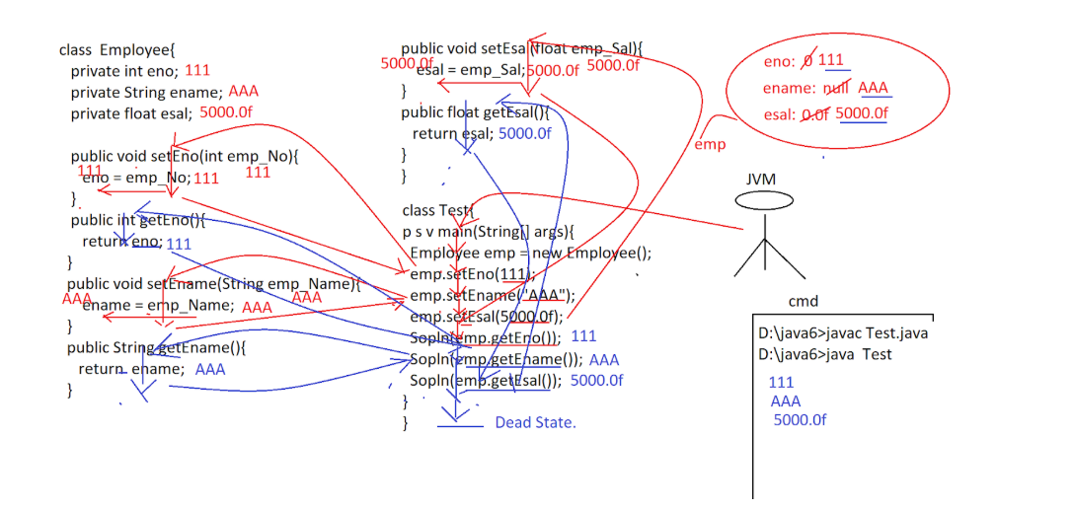

Variable-Argument Method
- In Java applications, if we declare a method with ‘n’ number of parameters then we can access that method by passing the same ‘n’ number of parameter values only, it is not possible to access that method by passing n+1 number of parameter values and n-1 number of parameter values.
- In Java applications, we want to define a method, and we want to access that method by passing a variable number of argument values. To achieve this requirement JAVA has provided a separate method convention in its JDK1.5 version that is “Variable-Argument Method” , in short “Var-Arg Method”.
- “Var-Arg” method is a Java method, it must have a Var-Arg parameter.

Syntax:
void m1(DataType … VarName){ // DataType[]
—------
}
- Where “DataType … VarName” is Var-Arg Parameter.
- Where Var-Arg parameter is internally an array of the same data type.

- If we access the Var-Arg method by passing some parameter values, then all the parameter values will be stored in the Var-Arg parameter represented array internally.

Ex:
package nagoor.java.oops;
class Demo {
public static int sum(int... a) {
int sum = 0;
System.out.println();
System.out.println("Length is: "+a.length);
for (int i : a) {
sum = sum + i;
}
return sum;
}
}
public class VariableArguementMethodDemo {
public static void main(String[] args) {
System.out.println("Sum is: " + Demo.sum(22, 33, 44, 55));
System.out.println("Sum is: " + Demo.sum(22));
System.out.println("Sum is: " + Demo.sum(1, 2, 3, 4, 5, 6));
}
}
Output:
Length is: 4
Sum is: 154
Length is: 1
Sum is: 22
Length is: 6
Sum is: 21

Q) Is it possible to provide other parameters along with the Variable-Argument parameter in the Variable-Argument method?
- Yes, it is possible to provide other parameters along with variable-argument parameter in variable-argument method, but the other parameters must be provided before the Variable-Argument parameter, because in Var-ARg methods , Var-Arg parameter must be the last parameter.
- EX:
  - void m1(int … a, float f){ } —-----> Invalid
  - void m1(float f, int … a){ } —---> Valid

Q) Is it possible to provide more than one Var-Arg parameter in a single Var-Arg method?
- No, it is not possible to provide more than one Var-Arg parameter in a single Var-Arg method, because In the Var-Arg method, Var-Arg parameter must be the last parameter.
- EX: void m1(int … a, float … b){ } —----> Invalid.

Object Creation Process in Java
In Java applications, we must create objects for the classes due to the following reasons.
- Java is an Object-oriented programming language, in java applications every operation is associated with objects only, so it is a minimum convention to create objects for the classes in java applications.
- In Java applications, we will create objects to store entities data temporarily, because in java applications, Objects are stored in Heap memory that is in RAM memory, it is temporary memory.
- In Java applications, if we want to access the members of any class then we must create an object for the respective class and we have to use the generated reference variable.

Syntax
ClassName refVar = new ClassName([ParamValues]);
Where ‘ClassName([ParamValues])’ is a constructor of the respective class.

class Employee{
}
Employee employee = new Employee();
- Where ‘Employee()’ is a constructor of the Employee class.
When a JVM executes object creation statement, that is ‘new’ keyword then JVM will perform the following actions.
- JVM will know which class object is creating based on the constructor’s name.
- JVM will search for the respective class .class file, if it is identified then JVM will load its bytecode to the memory.
- JVM will create java.lang.Class object in heap memory w.r.t the class bytecode loading.
- In java.lang.Class object, JVM can provide the complete metadata of the loaded class which includes class name, super class details, implemented interfaces details, variables data, methods data,......
- JVM will go to the loaded class and recognize all the instance variables and their data types.
- JVM will calculate minimal memory size for the object on the basis of the instance variables and their data types.
- JVM will request the Heap Manager to create an object with the generated minimal memory size.
- Heap Manager will create an object and Heap manager will assign an unique identity in the form an integer value called “Hashcode”.
- Heap Manager will send Object hashcode value to JVM, where JVM will convert Hashcode value into its Hexa-Decimal value called Object reference value.
- JVM will assign object reference value to a variable called Object reference variable.
- JVM will allocate memory for all the instance variables inside the object and JVM will provide initial values for the instance variables by checking initializations at class level declaration and at the constructor.
- If any instance variable is not having initialization at both class level declaration and constructor, then JVM will store default value based on the instance variable data type.

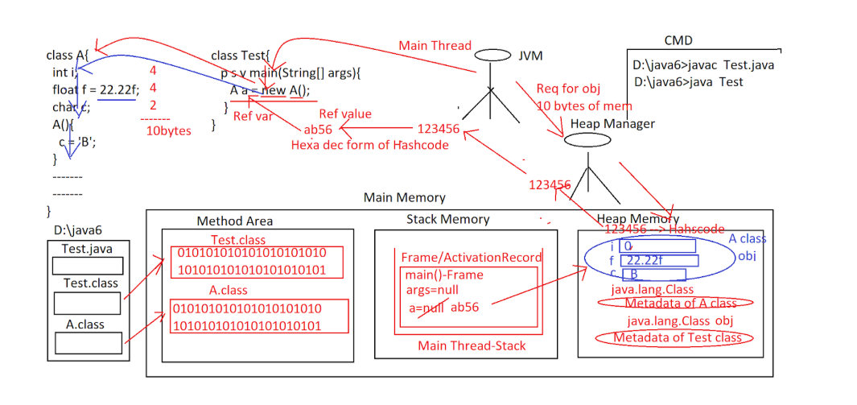
- To get the hashcode value of an object we have to use the following method.
  - public native int hashcode()
- Note: Native method is a method declared in Java and implemented in non java programming languages like C, C++, Pascal, H/W languages,......
- To get an Object reference value we have to use the following method.
  - public String toString()

Ex:
package nagoor.java.oops;
class ObjectDemo{
int a;
float f=12.3f;
char c='X';
ObjectDemo(){
c='A';
}
}
public class ObjectCreationprocess {
public static void main(String[] args) {
ObjectDemo obj=new ObjectDemo();
System.out.println(obj.a);
System.out.println(obj.f);
System.out.println(obj.c);

//Hashcode of the object
System.out.println(obj.hashCode());
//Reference value of the object
System.out.println(obj.toString());
System.out.println(obj);
}
}

Output:
0
12.3
A
1595428806
nagoor.java.oops.ObjectDemo@5f184fc6
nagoor.java.oops.ObjectDemo@5f184fc6

Value Initialization Flow:
Class level instance variable value->Constructor Level Instance [Over-rides Class level instance variable value]->If not value available at Class level or Constructor then Default value will be provided

Object Class
- In Java, there is a common and default superclass for every java class that is “java.lang.Object”.

- java.lang.Object class has the following 11 number of methods in order to provide these methods to every java class.
- hashCode()
- toString()
- equals()
- clone()
- finalize()
- getClass()
- wait()
- wait(long time)
- wait(long time, long time)
- notify()
- notifyAll()

Q)In Java, java.lang.Object class is a common and default superclass for every class, if we provide a superclass for a subclass explicitly then the respective subclass will have two super classes , one is java.lang.Object class and other one is the provided explicit superclass , it represents multiple inheritance , how can we say multiple inheritance is not possible in Java?
- java.lang.Object class is a common and default superclass for every java class when the class is not extending from any other class explicitly, if the present class is extending from a superclass explicitly then java.lang.Object class is superclass to the sub class indirectly like through Multilevel inheritance not through multiple inheritance.
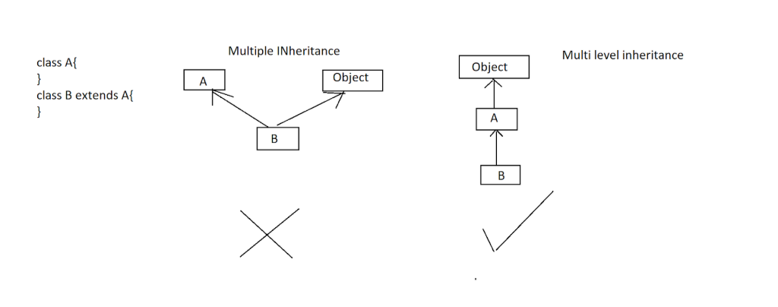

In Object class, the toString() method was implemented in such a way that to return a string containing “ClassName@RefVal”.
- In Java applications, if we pass a particular object reference variable as parameter to System.out.println() method then JVM will access toString() method over the provided object reference variable, in this case, JVM will search for toString() method in the respective class first, if no toString() method is available explicitly in the respective class then JVM will search for the toString() method in the respective class’s super class, if no super class available explicitly then JVM will search for toString() method in the common and default superclass that is Object class, Object class provided toString() method will return a string contains “ClassName@RefValue”.
Ex:
class Employee{
}
class Test{
public static void main(String[] args){
Employee emp = new Employee();
String ref = emp.toString();
System.out.println(ref);
System.out.println(emp.toString());
System.out.println(emp);// Sopln(emp.toString());
}
}
- In the above context, if we want to display our own data when we pass an object reference variable as parameter to System.out.println() method then we have to define our own toString() method in the respective class.
EX:
class Employee{
int eno = 111;
String ename = "Durga";
float esal = 50000.0f;
String eaddr = "Hyd";

public String toString(){
System.out.println("Employee Details");
System.out.println("-----------------------");
System.out.println("Employee Number : "+eno);
System.out.println("Employee Name : "+ename);
System.out.println("Employee Salary : "+esal);
System.out.println("Employee Address : "+eaddr);
return "";
}
}
class Test{
public static void main(String[] args){
Employee emp = new Employee();
System.out.println(emp);
}
}
Employee Details
-----------------------
Employee Number : 111
Employee Name : Durga
Employee Salary : 50000.0
Employee Address : Hyd

- In Java , some predefined classes like String, Exception, Thread, Collection classes, wrapper classes,....... are not depending on the Object class provided toString() method, they have their own toString() methods to display their own data when we pass the respective class object reference variable as parameter to System.out.println() method.
Ex:
import java.util.*;
class Test{
public static void main(String[] args){
String str = new String("abc");
System.out.println(str);
Exception e = new Exception();
System.out.println(e);
Thread t = new Thread();
System.out.println(t);
List list = List.of(10,20,30,40,50);
System.out.println(list);
}
}
Output:
abc
java.lang.Exception
Thread[Thread-0,5,main]
[10, 20, 30, 40, 50]

Types of Objects
- In Java, there are two types of Objects.
- Immutable Objects
- Mutable Objects

Q) What is the difference between Immutable Objects and Mutable Objects?

Or

What is the difference between String and StringBuffer?
- Immutable objects are java objects, they will not allow modifications on their content, if we are trying to perform modifications on immutable objects data then immutable objects are allowing modifications but the resultant modified data will not be stored back in the original objects, where the resultant modified data will be stored by creating a new object for the same class.
- EX:
  - String class objects are immutable.
  - All Wrapper classes objects are immutable.

- Mutable objects are the java objects; they are able to allow modifications on their content directly.
- All Java objects are by default mutable objects.
EX: String Buffer
Ex:
public class MutableAndImmutableObjects {
public static void main(String[] args) {
String str1 = new String("Durga ");
String str2 = str1.concat("Software ");
String str3 = str2.concat("Solutions");
System.out.println(str1);// Durga
System.out.println(str2);// Durga Software
System.out.println(str3);// Durga Software Solutions
System.out.println();
StringBuffer sb1 = new StringBuffer("Durga ");
StringBuffer sb2 = sb1.append("Software ");
StringBuffer sb3 = sb2.append("Solutions");
System.out.println(sb1);// Durga Software Solutions
System.out.println(sb2);// Durga Software Solutions
System.out.println(sb3);// Durga Software Solutions
}
}
Output:
Durga
Durga Software
Durga Software Solutions

Durga Software Solutions
Durga Software Solutions
Durga Software Solutions
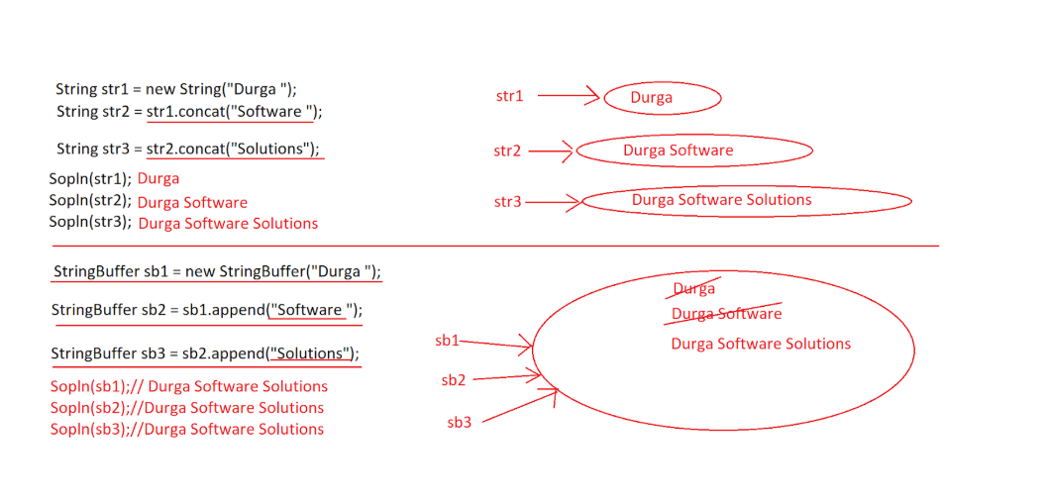

Q) What is the difference between Object and Instance?
- Object is a memory block to store data.
- Instance is the layer of data or copy of data that existed at a particular point of time in an object.
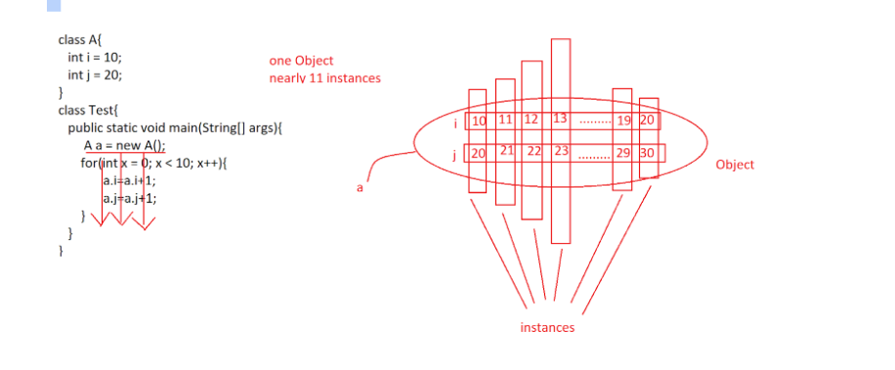

Constructor
- Constructor is a Java feature; it can be used to create objects.
- The role of the constructor in object creation is to provide initial values inside the objects.
- In Java applications, constructors are executed exactly at the time of creating objects only, not before creating objects and not after creating objects.
- In java applications, constructors are utilized to provide initializations to the class level variables.
- Constructors’ names must be the same as the respective class name.
- Constructors are not having return types.
- Constructors are not allowing the access modifiers like static , final, abstract,.....
- Constructors are able to allow the access modifiers like public, protected, <default> and private.
- Constructors are able to allow throws keyword to bypass the exception from the present constructor to the caller of the constructor.

Syntax
[AccessModifier] ClassName([ParamList])[throws ExceptionList]{
—----instructions—-----
}

Points to be Remembered
- In java applications, constructor name must be same as the respective class name, in the case if we provide different name to the constructor not same as the class name then compiler will raise an error like “Invalid Method declaration, return type required”, because the compiler treats the provided constructor as normal java method and it is checking the provided constructor syntax against to the method syntax, in methods return type is mandatory.

- In Java applications, Constructors do not have return types, in the case if we provide a return type to the constructor then the provided constructor will be converted to a java method and if we access that constructor as like a java method then it will be executed.

- In Java applications, Constructors are not allowing the access modifiers like static, final, abstract,....., in the case if we provide the access modifiers like static, final, abstract,... to the constructor then the compiler will raise an error like “Modifier XXX not allowed here”.

- In Java applications, constructors are able to allow the access modifiers like public, protected, <default> and private , in the case if we declare a constructor as private then it must be accessed within the same class, that is, objects for the class must be created inside the same class, not possible to create objects in outside of the respective class.

Types of Constructors

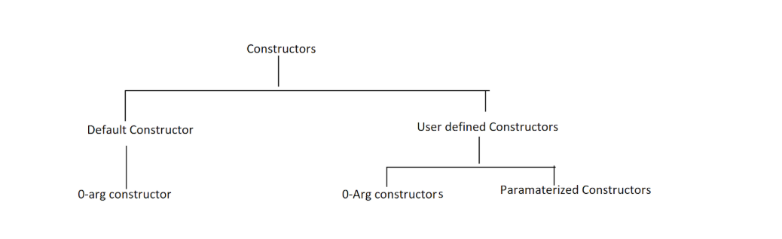

Default Constructor
- Default constructor is a 0-arg constructor, it will be provided by the compiler when we have not provided any constructor explicitly in the class, if we provide at least one constructor in the class then the compiler will not provide default constructor.
- The default constructor will have the same scope of the respective class.
- Note: In Java, by default , all default constructors are 0-arg constructors, but all 0-arg constructors need not be default constructors, some 0-arg constructors that are provided by the compiler are default constructor, some other 0-arg constructors which are provided by the developers are user defined constructors.

User Defined Constructors
- These are the constructors provided by the developers as per their application requirement.
- There are two types of User defined constructors.
- 0-arg constructors
- Parameterized Constructors
- If we declare any constructor without the parameters, then that constructor is a 0-arg constructor.
- If we declare any constructor with at least one parameter, then that constructor is a Parameterized constructor.

Ex:
class Account{
String accNo;
String accHolderName;
String accType;
int balance;

public Account(String acc_No, String acc_Holder_Name, String acc_Type, int acc_Balance){
accNo = acc_No;
accHolderName = acc_Holder_Name;
accType = acc_Type;
balance = acc_Balance;
}
public void displayAccountDetails(){
System.out.println("Account Details");
System.out.println("---------------------");
System.out.println("Account Number : "+accNo);
System.out.println("Account Holder Name : "+accHolderName);
System.out.println("Account Type : "+accType);
System.out.println("Account Balance : "+balance);
}
}
class Test{
public static void main(String[] args){
Account account1 = new Account("a111", "Durga", "Savings", 50000);
account1.displayAccountDetails();
Account account2 = new Account("a222", "Vishnu", "Savings", 60000);
account2.displayAccountDetails();
}
}

Constructor Overloading
- If we declare more than one method with the same name and with the different parameter list, then it is called “Method Overloading”.
- Similarly, If we declare more than one constructor with the same name and with the different parameter list then it is called “Constructor Overloading”.
Ex:
class Calculator{
int i, j, k;

Calculator(){
}
Calculator(int x){
i = x;
}
Calculator(int x, int y){
i = x;
j = y;
}
Calculator(int x, int y, int z){
i = x;
j = y;
k = z;
}
public void add(){
System.out.println("ADD : "+(i+j+k));
}

}
class Test{

public static void main(String[] args){
Calculator cal1 = new Calculator();
cal1.add();

Calculator cal2 = new Calculator(10);
cal2.add();

Calculator cal3 = new Calculator(10,20);
cal3.add();

Calculator cal4 = new Calculator(10,20,30);
cal4.add();
}
}
Output:
ADD : 0
ADD : 10
ADD : 30
ADD : 60
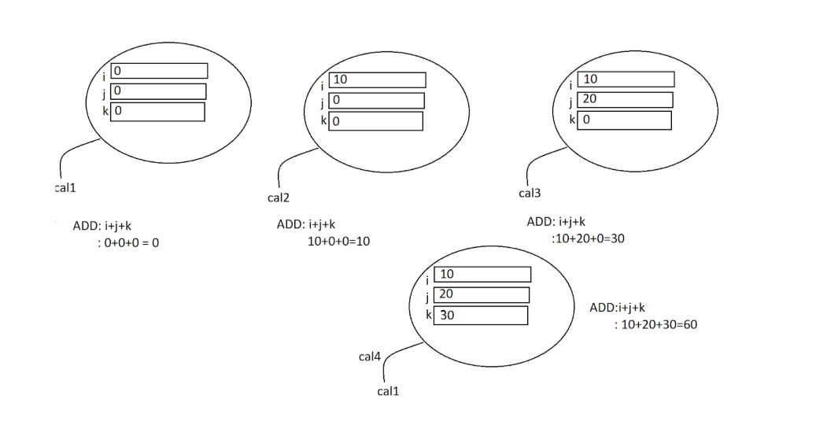

Instance Context / Instance Flow of Execution
- In Java applications, when we load a class bytecode to the memory, automatically a separate context will be created called “Static Context” to perform all the activities while loading class bytecode.
- In Java applications, when we create an object at heap memory, automatically a separate context will be created called “Instance Context” to perform all the activities while creating and initializing the object.
- In Java applications, instance context is represented in the form of the following three elements.
- Instance Variables
- Instance Methods
- Instance Blocks

Instance Variables
- If any variable changes its value from one instance to another instance of an object, then that variable is called “Instance Variable”.
- In Java applications, we can declare instance variables at class level as non-static variables.
- In Java applications, instance variables are recognized and initialized just before executing the respective class constructor automatically.
- In the current class we can access instance variables directly without creating an object, but if we access instance variables outside of the current class then we must create an object for the respective class and we have to use the generated reference variable.
Note: If we access an instance variable by using a reference variable containing null value then JVM will raise an exception like java.lang.NullPointerException.
- In Java applications, instance variables data will be stored inside the objects at heap memory.
- In Java applications, a separate copy of the instance variable data will be created for each object, if we perform modifications on an instance variable in an object then that modification is available up to the respective object, that modifications will not be reflected to the other objects.
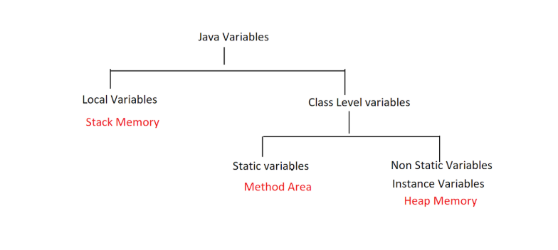
Ex:
package nagoor.java.oops;
class Instance {
int a = 10;
{
System.out.println("I am Instance Block");
}
Instance(){
System.out.println("I am Constructor");
}
}
public class InstanceVariables {
public static void main(String[] args) {
Instance i = new Instance();
System.out.println(i.a);
Instance i2 = new Instance();
System.out.println(i2.a);
// i = null;
//
// try{
// System.out.println(i.a);
// }
// catch (Exception e){
// e.printStackTrace();
// }
System.out.println("End ");
}
}
Output:
I am Instance Block
I am Constructor
10
I am Instance Block
I am Constructor
10
End

Instance Method
- Instance method is a Java method; it is a set of instructions representing a particular action of an entity.
- Instance methods are recognized and executed now when we access that method.
- If we declare any non-static method in a class, then that method is an instance method.
- Within the same class we can access instance methods directly without using any reference variable, without using any keyword and without creating objects, but if we want to access instance methods outside of the current class then we have to create an object for the respective class and we have to use the generated reference variable.
Note: If we access any instance method by using a reference variable containing null value then JVM will raise an exception like java.lang.NullPointerException.

Instance Block
- It is a set of instructions, it will be recognized and executed automatically just before executing the respective class constructor like instance variables.
- Instance blocks are having the same power of constructors, but it is not utilized like constructors in the application development.
Syntax:
{
—---instructions—---
}

This keyword
- ‘this’ is a Java keyword; it can represent the current class object.

In Java applications, we can utilize ‘this’ keyword in the following four ways.
- To refer current class variables
- To refer current class methods
- To refer current class constructor
- To return Current class Object

To Refer Current class Variables
- To refer to current class variables if we want to use ‘this’ then we must use the following syntax.
- this.varName
- In Java applications, if we have the same variables at local and at class level, where to refer class level variable over the local variable there we will use ‘this’ keyword.
Ex 1:
package com.durgasoft.test;
class A{

int i = 10;
int j = 20;

A(int i, int j){
System.out.println(i+" "+j);
System.out.println(this.i+" "+this.j);
}
}
public class Test {
public static void main(String[] args) {
A a = new A(30,40);
}
}
OP:
30 40
10 20
Ex 2: Java Bean Class
Employee.java
package com.durgasoft.beans;
public class Employee {
private int eno;
private String ename;

public int getEno() {
return eno;
}
public void setEno(int eno) {
this.eno = eno;
}
public String getEname() {
return ename;
}
public void setEname(String ename) {
this.ename = ename;
}
}
public class Test {
public static void main(String[] args) {

Employee employee = new Employee();
employee.setEno(111);
employee.setEname("Durga");

System.out.println("Employee Details");
System.out.println("------------------------");
System.out.println("Employee Number : "+employee.getEno());
System.out.println("Employee Name : "+employee.getEname());
}
}

To refer Current class methods by using this keyword
- If we want to refer to the current class method by using ‘this’ keyword then we must use the following syntax.
- this.methodName([ParamValues]);
- Note: In the current class, to access current class methods it is not required to use any keyword, directly we can access current class methods without using reference variables and without using ‘this’ keyword.
Ea 1:
package com.durgasoft.test;
class A{
void m1() {
System.out.println("m1-A");
m2();
this.m2();
}
void m2() {
System.out.println("m2-A");
}
}
public class Test {
public static void main(String[] args) {
A a = new A();
a.m1();

}
}
Output:
m1-A
m2-A
m2-A

To refer current class constructors by using ‘this’ keyword
If we want to access the current class constructor by using this keyword then we have to use the following syntax.
this([ParamValues]);
Ex 1:
class A{
A(){
this(10);
System.out.println("A-Con");
}
A(int i){
this(22.22f);
System.out.println("A-int-param-con");
}
A(float f){
this(33.3333);
System.out.println("A-float-param-con");
}
A(double d){
System.out.println("A-double-param-con");
}
}
class Test{
public static void main(String[] args){
A a = new A();
}
}

Output:
A-double-param-con
A-float-param-con
A-int-param-con
A-Con
- In the above program, all the current constructors are executed in a chain fashion by using this keyword, so this feature is called “Constructor Chaining”.

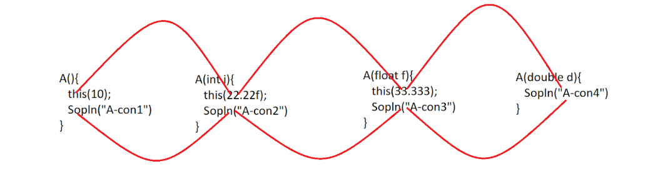
- In the above program we have written more than one constructor with the same name and with a different parameter list then this feature is called “Constructor Overloading”.

- If we want to refer to the current class constructor by using ‘this’ keyword, then the respective this statement must be the first statement.
- If we want to refer to the current class constructor by using ‘this’ keyword then we have to use the respective this statement in the other current class constructor only, not in the normal java method.
- it is not possible to refer to more than one current class constructor by using this keyword from a single current class constructor, because in the constructors this statement must be the first statement.

To return Current Class Object from the method
- If we want to return a current class object by using this keyword, then we must use the following syntax.
- return this;
- Note: In the above program, when we access getRef1() method every time JVM executes new keyword, so JVM will create new object every time, it will create duplicate objects for the class, in this context, if we want to return the same object on which we have accessed this method then we have to return ‘this’.
EX:
package com.durgasoft.test;
class A{
A getRef1(){
A a = new A();
return a;
}
A getRef2() {
return this;
}
}
class Test{
public static void main(String[] args){
A a = new A();
System.out.println(a);// A@a111
System.out.println();

System.out.println(a.getRef1());// A@a222
System.out.println(a.getRef1());// A@a333
System.out.println(a.getRef1());// A@a444
System.out.println();

System.out.println(a.getRef2());// A@a111
System.out.println(a.getRef2());// A@a111
System.out.println(a.getRef2());// A@a111

}
}

OP:
com.durgasoft.test.A@626b2d4a
com.durgasoft.test.A@5e265ba4
com.durgasoft.test.A@156643d4
com.durgasoft.test.A@123a439b
com.durgasoft.test.A@626b2d4a
com.durgasoft.test.A@626b2d4a
com.durgasoft.test.A@626b2d4a

Ex 2:
package nagoor.java.oops;
class Demo1 {
Demo1 getObject() {
return new Demo1();
}
Demo1 getObjectUsingThis() {
return this;
}
}
public class THisKeywordToReturnCurrentClassObject {
public static void main(String[] args) {
Demo1 d = new Demo1();
System.out.println(d.getObject());
System.out.println(d.getObject());
System.out.println();
System.out.println(d.getObjectUsingThis());
System.out.println(d.getObjectUsingThis());
}
}
Output:
nagoor.java.oops.Demo1@5f184fc6
nagoor.java.oops.Demo1@3feba861

nagoor.java.oops.Demo1@5b480cf9
nagoor.java.oops.Demo1@5b480cf9

static keyword
- ‘static’ is a java keyword, it can improve shareability in java applications.
- In Java applications, we can utilize static keyword in the following four ways.
- Static Variables
- Static Methods
- Static Blocks
- Static Import

Static Variables
- Static variable is a java variable, it will be recognized and initialized at the time of loading the respective class bytecode to the memory.
- Static variable is a java variable, it will share its last modified value to the past objects [Previous Objects] which we have already created and to the future objects which we are going to create.
- Static variables must be declared at class level only, it is not possible to declare static variables as local variables. If we declare any static variable as a local variable, then the compiler will raise an error.
- In Java applications, we can access static variables either by creating object for the respective class or by using the respective class name directly. It is suggestible to access static variables by using class names.
- In Java applications, if we access any instance variable by using a reference variable containing null value then JVM will raise an exception like java.lang.NullPointerException, but if we access any static variable by using a reference variable containing null value then JVM will not raise any exception, here JVM will get the value of the static variable.
- In Java applications, we can use ‘this’ keyword to access current class static variable.
- Static variables data will be stored in the Method Area.
Ex 1:
package com.durgasoft.test;
class A{
static int i = 10;
int j = 20;
void m1() {
//static int k = 30; --> Error Local variable cannot be static
System.out.println("m1-A");
System.out.println(this.i);
}
}
class Test{
public static void main(String[] args){
A a = new A();
System.out.println(a.i);
System.out.println(A.i);

A a1 = null;
//System.out.println(a1.j);-->java.lang.NullPointerException

System.out.println(a1.i);

a.m1();

}
}
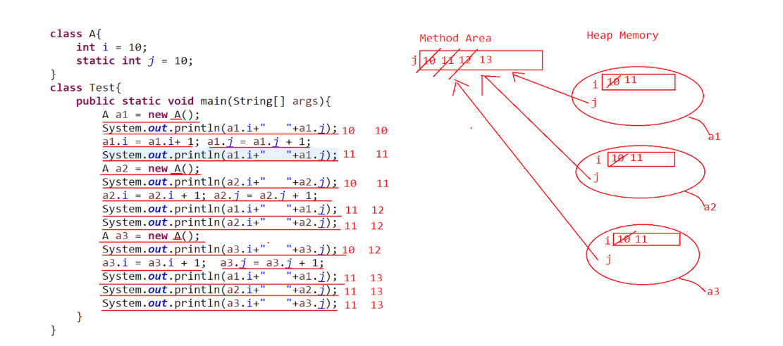
Differences between Instance variables and Static variables?
- To declare an instance variable no need to use any special keyword.
To declare a static keyword, we need a ‘static’ keyword.
- A separate copy of the instance variable will be created at each every object.
Single copy of the static variable will be shared to all the objects of the respective class.
- The scope of the instance variable is up to a single object.
The scope of the static variable is up to all the objects of the respective class.
- Instance variables will share their value to a single object, that is less shareability.
Static variables will share their values to all the objects, that is more shareability.
- Instance variables data will be stored inside heap memory in the form of objects.
Static variables data will be stored inside the method area.
- Instance variables are recognized and initialized just before executing the respective class constructor.
Static variables are recognized and initialized at the time of loading the respective bytecode to the memory.
- To access instance variables, we must create an object for the respective class.
To access static variables either we can create objects, or we can use the respective class name directly.

- java.lang.NullPointerException is possible in the case of instance variables.
java.lang.NullPointerException is not possible in the case of static variables.
- We are able to access Instance variables inside the instance methods only , not possible to access instance variables inside the static methods.
We can access static variables in both static methods and
instance methods.

Static Method
- Static method is a set of instructions , it will be recognized and executed the moment when we access that method.
- Static methods can allow only static members of the current class; static methods are unable to allow instance members of the current class.
- If we want to access instance members inside the static method, then we have to create an object for the respective class and we must use the generated reference variable explicitly.
- In Java applications, we can access static methods either by creating objects for the respective class or by using the respective class name directly, where class name is suggestible to access static methods.
- If we access an instance method by using a reference variable containing null value then JVM will raise an exception like java.lang.NullPointerException, but if we access a static method by using a reference variable containing null value then JVM will not raise any exception.
- Static Methods are not allowing ‘this’ keyword in their body, but we are able to use ‘this’ keyword to access current class static methods.
Ex 1:
class A{
int i = 10;
static int j = 20;
static void m1() {
System.out.println("m1-A");
//System.out.println(i); --> Error
System.out.println(j);
//System.out.println(this.j); --> Error
}
void m2() {
System.out.println("m2-A");
System.out.println(i);
System.out.println(j);
this.m1();
}
}
class Test{
public static void main(String[] args){
A a = new A();
a.m1();
A.m1();

A a1 = null;
//a1.m2(); --> java.lang.NullPointerException
a1.m1();
a.m2();
}
}
Output:
m1-A
20
m1-A
20
m1-A
20
m2-A
10
20
m1-A
20
Note: From Java 7 version, first JVM will check whether main () method exist or not, if main() method exist then only JVM will load main class bytecode to the memory, if main() does not exist in the main class then JVM will not main class bytecode to the memory.

Static blocks
- Static block is a set of instructions, which are recognized and executed automatically at the time of loading the respective class bytecode to the memory.
- Static blocks can allow only static members of the current class, static blocks are not allowing instance members of the current class.
- If we want to access instance members inside the static block, then we must create an object for the respective class and we have to use the generated reference variable.
- Static blocks are not allowing ‘this’ keyword in their body.

Syntax:
static{
—-----
—-----
—-----
}
EX:
class A{
int i = 10;
static int j = 20;
static{
System.out.println("SB-A");
//System.out.println(i);--> Error
System.out.println(j);
//System.out.println(this.j); ---> Error
}
}
class Test{
public static void main(String[] args){
A a = new A();
}
}

Static import
- In general, in java applications, if we have any class in a package and if we want to use that class in any java file then we must import the respective package to the present file and we have to use the respective class in the java file.
EX:
import com.durgasoft.core.*;
import java.util.ArrayList;
import java.io.BufferedReader;
—----
—----
- If we want to import the static members[not instance members] of a particular class to the present java file then we have to use “Static import”.
- If we import static members of a particular class by using “static import” in the present java file then we can access that static members without using class name and without using reference variables of the respective class, we can access that static members as local members.
Syntax#1:
import static packageName.className.*;
- It can import all static members of the specified class from the specified package.
Syntax#2:
- import static packageName.className.staticMember;
It can import the specified static member from the specified package.
Ex 1:
In java.lang.Thread class , there are three static variables.
public static final int MIN_PRIORITY = 1;
public static final int NORM_PRIORITY = 5;
public static final int MAX_PRIORITY = 10;

EX:
In java.lang.System class, the variables like out , err, in are static members

EX:
import static java.lang.Thread.*;
import static java.lang.System.out;
class Test{
public static void main(String[] args){
out.println(MIN_PRIORITY);
out.println(NORM_PRIORITY);
out.println(MAX_PRIORITY);
}
}
Output:
1
5
10

Static Context / Static Flow of execution
- Static context is represented by the following three elements.
- Static Variables
- Static Methods
- Static Blocks
- Where static variables and static blocks are recognized and executed automatically at the time of loading the respective class bytecode to the memory, where static methods are recognized and executed the moment when we access that method.
Ex 1:
class A{
static {
System.out.println("SB-A");
}
static int m1() {
System.out.println("m1-A");
return 10;
}
static int i = m1();
}
class Test{
public static void main(String[] args){
A a = new A();
}
}
OP:
SB-A
m1-A
Ex 2:
class A{
static int i = m1();
static {
System.out.println("SB-A");
}
static int m1() {
System.out.println("m1-A");
return 10;
}
}
class Test{
public static void main(String[] args){
A a1 = new A();
A a2 = new A();
}
}
OP:
m1-A
SB-A
Ex 3:
class A{
A(){
System.out.println("A-Con");
}
static {
System.out.println("SB-A");
}
int m1() {
System.out.println("m1-A");
return 10;
}
static int i = m2();
{
System.out.println("IB-A");
}
int j = m1();
static int m2() {
System.out.println("m2-A");
return 20;
}
}
class Test{
public static void main(String[] args){
A a = new A();
}
}
Output:
SB-A
m2-A
IB-A
m1-A
A-Con

Ex 3:
class A{
{
System.out.println("IB-A");
}
int m1() {
System.out.println("m1-A");
return 10;
}
int i = m1();

A(){
System.out.println("A-Con");
}

static {
System.out.println("SB-A");
}
static int m2() {
System.out.println("m2-A");
return 20;
}
static int j = m2();
}
class Test{
public static void main(String[] args){
A a1 = new A();
A a2 = new A();
}
}
SB-A
m2-A
IB-A
m1-A
A-Con
IB-A
m1-A
A-Con

Flow of Execution of static and instance context
Static block or variable [One per class]->Instance block or variables [Once per Object]->Constructor

Class.forName()
- To load class byte code to method area without creating object for an class we use Class.forName()
- When we create an object for a particular class, JVM will perform the following two tasks automatically.
- Loading the respective class bytecode to the memory.
- Creating object for the respective class.
- As per the requirement, we want to load a particular class bytecode to the memory, not to create any object for the respective loaded class, to achieve this requirement we must use the following method from java.lang.Class.
public static Class forName(String className)throws ClassNotFoundException
EX: Class cls = Class.forName(“Employee”);
Ex:
package com.durgasoft.test;
class A{
static {
System.out.println("Class Loading....");
}
A(){
System.out.println("Object Creating.....");
}
}
class Test{
public static void main(String[] args) throws ClassNotFoundException{
Class cls = Class.forName("com.durgasoft.test.A");
}
}
When we execute the above instruction, JVM will perform the following actions.
- JVM will take the provided class name from forName() method.
- JVM will search for the respective class’s .class file at the following locations.
    - At the current location from where we are executing the program.
    - At the java predefined library
    - At the locations referred by “classpath” environment variable.
- If the required .class file is not available at all the above locations then JVM will raise an exception like “java.lang.ClassNotFoundException”.
- If the required .class file is available at either of the above locations
then JVM will load its bytecode to the memory.
- When a class bytecode is loaded at Method Area, automatically JVM
will create an object for java.lang.Class with the metadata of the
loaded class, where the metadata include the following details.
- Name of the class.
- Access modifiers of the class
- Super class details
- Implemented interfaces details
- Variables details
- Constructors’ details
- Methods details
—----
—----

newInstance() Method
- If we load any class bytecode to the memory by using Class.forName() method and if we want to create an object for the loaded class, then we must use the following method from java.lang.Class .
- public Object newInstance()throws InstantiationException, IllegalAccessException

package com.durgasoft.test;
class A{
static {
System.out.println("Class Loading....");
}
A(){
System.out.println("Object Creating.....");
}
}
class Test{
public static void main(String[] args) throws ClassNotFoundException, InstantiationException, IllegalAccessException{
Class cls = Class.forName("com.durgasoft.test.A");
Object obj = cls.newInstance();
}
}

When we execute cls.newInstance() method, JVM will perform the following actions.
- JVM will go to the loaded class, where JVM will search for non-private and 0-arg constructor.
- If 0-arg and non-private constructor is available in the loaded class, then JVM will execute that constructor and JVM will create an object for the respective class.
- If the constructor is a parameterized constructor, there is no 0-arg constructor in the loaded class then JVM will raise an exception like java.lang.InstantiationException.
- If the constructor is a private constructor, there is no other constructor then JVM will raise an exception like java.lang.IllegalAccessException.
- If the constructor is private and parameterized then JVM will raise java.lang.InstantiationException.

Ex 1: Exception Demo
package com.durgasoft.test;
class A{
static {
System.out.println("Class Loading....");
}
A(int i){
System.out.println("Object Creating.....");
}
}
class Test{
public static void main(String[] args) throws ClassNotFoundException, InstantiationException, IllegalAccessException{
Class cls = Class.forName("com.durgasoft.test.A");
Object obj = cls.newInstance();
}
}
Class Loading....
Exception in thread "main" java.lang.InstantiationException: com.durgasoft.test.A

- Note: IN Jdbc applications, we must load and register the driver, that is we must load driver class bytecode to the memory, for this we have to use Class.forName() method.
- EX: Class cls = Class.forName(“oracle.jdbc.OracleDriver”);
- Note: In Servlets execution, Server must perform Servlet Loading and Servlet Instantiation in Servlet lifecycle, where to perform Servlet Loading Server must use Class.forName() method, where to perform Servlet Instantiation Server must execute newInstance() method.
EX:
Class cls = Class.forName(“WelcomeServlet”); —> Servlet Loading
Object obj = cls.newINstance(); —-----> Servlet Instantiation

- Note: EJB is a server side component, it will be executed by the application Server by following its lifecycle, where in EJBs lifecycle Application Server has to perform EJB loading and EJBs instantiation, where to perform EJBs loading Application Server has to execute Class.forName() method , where to perform EJBs instantiation Application Server has to execute cls.newInstance() method.

Factory Method
- If any Java method returns a particular class object reference value, then that Java method is called “Factory Method”, where the Factory method can return either the same class object or different class object.
- Factory method is an idea provided by “Factory Method Design Pattern”.
Ex:
class F{
private F(){}
static F getRef(){
return new F();
}
}
public class FactoryMethodDemo {
public static void main(String[] args) {
F f=F.getRef();
System.out.println(f);
}
}

There are two types of Factory Methods.
- Static Factory Method
- Instance Factory Method

Static Factory Method
- If any static method returns a particular class object reference value then that static method is Static Factory Method.
EX:
Class cls = Class.forName(“A”);
NumberFormat nf = NumberFormat.getInstance();
Runtime rt = Runtime.getRuntime();

Instance Factory Method
- If any instance method returns a particular class object then that instance method is called “Instance Factory Method”.
- Note: In general, Factory methods will be used in the preparation of Singleton classes.
EX: Majority of the String class methods are Instance Factory Methods.
EX: String str = “Durga Software Solutions”;
String str1 = str.toUpperCase();
String str2 = str.trim();
String str3 = str.concat(“ Hyderabad”);
—-----
—-----

Singleton Classes
If any class allows you to create a single object for it, then that class is called “Singleton Class”.
In Java, Singleton class is an idea provided by the “Singleton Design Pattern”.
To create Singleton classes in java applications we have to use the following steps.
- Declare a user defined class.
- Declare a private constructor
- Declare a static reference variable of the same class with null value.
- Declare a static factory method with the following implementation.
  - Check whether any object is created for the current class or not by checking static reference variable value is null or not, if the static reference variable value is null then there is no object for the respective class previously, if the static reference variable value is not null then there is an object for the current class previously.
  - If no object is created previously then create a new object for the current class and return that object reference.
  - If any object has existed previously then return the existing object without creating a new object.
- In main class, in main() method , Access static factory method
multiple times and get the same reference value.
Ex:
package com.durgasoft.test;
class A {
static A a = null;// a=a111
private A(){
//System.out.println("A-Con");
}
static A getRef() {
if(a == null) {
a = new A();//A@a111
}
return a;
}
}
class Test {
public static void main(String[] args) {
A a1 = A.getRef();// a1 = A@a111
A a2 = A.getRef();// a2 = A@a111
A a3 = A.getRef();// a3 = A@a111

System.out.println(a1);// A@a111
System.out.println(a2);// A@a111
System.out.println(a3);// A@a111
}
}
OP:
com.durgasoft.test.A@626b2d4a
com.durgasoft.test.A@626b2d4a
com.durgasoft.test.A@626b2d4a
Ex 2:
- In java applications, a static block will be executed exactly one time. If we create an object for a particular class inside a static block then only one object will be created for the respective class, so it makes the class as Singleton class.
package com.durgasoft.test;
class A {
static A a = null;// a=a111
static {
a = new A();
}
private A(){
//System.out.println("A-Con");
}
static A getRef() {

return a;
}
}
class Test {
public static void main(String[] args) {
A a1 = A.getRef();// a1 = A@a111
A a2 = A.getRef();// a2 = A@a111
A a3 = A.getRef();// a3 = A@a111

System.out.println(a1);// A@a111
System.out.println(a2);// A@a111
System.out.println(a3);// A@a111
}
}
Ex 3:
- If we create an object along with a static reference variable then only one object will be created for the respective class, because static variables will be recognized and initialized only one time at the time of loading the respective bytecode to the memory.
package com.durgasoft.test;
class A {
private static A a = new A();// a=a111

private A(){
//System.out.println("A-Con");
}
static A getRef() {

return a;
}
}
class Test {
public static void main(String[] args) {
A a1 = A.getRef();// a1 = A@a111
A a2 = A.getRef();// a2 = A@a111
A a3 = A.getRef();// a3 = A@a111

System.out.println(a1);// A@a111
System.out.println(a2);// A@a111
System.out.println(a3);// A@a111
}
}

- In general, in MVC based web applications we will use a servlet as controller, where Servlet is a java class.
- As per the MVC rules and regulations, per MVC web application only one controller must be provided, that is, the controller servlet class must allow to create only one object, not to allow to create multiple objects, hence the Controller Servlet class must be a “Singleton” class.

‘final’ Keyword
- ‘final’ is a Java keyword, it can be used to declare constant expressions.
- The main advantage of the ‘final’ keyword is “Security”.
In Java applications we can utilize the final keyword in the following three ways.
- final variables
- final methods
- final classes

final variables
- It is a Java variable, it will not allow modifications on its value, if we are trying to perform modifications over its value then the compiler will raise an error.
- In general, final variables are not allowing re-assignments
EX:
final int i = 10;
i = i + 10; —--> Error

Ex:
In the bank applications, once account number is created then there is no chance of updating account number, here remaining account details may be updated but account number must not be updated, so accNo variable must be declared as final variable.

Ex:
In Gmail, Facebook, once id is created then it is not possible to change id value, but remaining details like address details, school and college details…. May be changed, so that id value must be declared as final variable.
Ex:
In the loops, loop variables must not be declared as final variables, because loop variables must have changes in their values in order to rotate the loop.
EX:
for(final int i = 0; i < 10; i++){// —--> Error
—----
}

‘final’ Methods
- ‘final’ method is a Java method, it will not allow change in its functionality, that is, it will not allow overriding operation.
EX:
class Teacher{
public final void teach(){
System.out.println(“Teacher teaches on Black Board”);
}
}
class Professor extends Teacher{
public void teach(){
System.out.println(“Profession teaches on Marker Board”);
}
}
Status: Compilation Error

EX:
class Teacher{
public void teach(){
System.out.println(“Teacher teaches on Black Board”);
}
}
class Professor extends Teacher{
public final void teach(){
System.out.println(“Profession teaches on Marker Board”);
}
}
Status: no Compilation Error

EX:
class Account{
public final int getMinBal(){
return 25000;
}
}
class SalaryAccount extends Account{
public int getMinBal(){
return 10000;
}
}
Status: Compilation Error

‘final’ Classes
- ‘final’ class is a Java class, it will not inherit, that is it will not allow subclasses.
- In the case of inheritance, a superclass must not be declared as final, but we may declare a subclass as final class.
Ex:
class A{
}
class B extends A{
}
Status: Valid

Ex:
final class A{
}
class B extends A{
}
Status: Invalid
EX:
class A{
}
final class B extends A{
}
Status: Valid
- In java applications, we can declare constant variables by using ‘final’ keyword, but Java has given a suggestion to declare constant variables like with “public static final”.
EX1:
package com.durgasoft.test;
class UserStatus{
public static final String AVAILABLE = "User Available";
public static final String BUSY = "User Busy";
public static final String IDLE = "User Idle";
}
public class Test {
public static void main(String[] args) {
System.out.println(UserStatus.AVAILABLE);
System.out.println(UserStatus.BUSY);
System.out.println(UserStatus.IDLE);
}
}

Enum
- “enum” is a container, it can be used to declare constant variables.
- In java applications, we can declare constant variables by using ‘final’ keyword, but Java has given a suggestion to declare constant variables like with “public static final”.
- Where the main intention of declaring constant variables with the public is to access that variable throughout the application.
EX1:
In java.lang.Thread class, there are three constant variables with “public static final”.
public static final int MIN_PRIORITY = 1;
public static final int NORM_PRIORITY = 5;
public static final int MAX_PRIORITY = 10;
EX2:
In java.lang.System class , there are variables with “public static final”.

public static final InputStream in;
public static final PrintStream out;
public static final PrintStream err;
EX 3:
package com.durgasoft.test;
class UserStatus{
public static final String AVAILABLE = "User Available";
public static final String BUSY = "User Busy";
public static final String IDLE = "User Idle";
}
public class Test {
public static void main(String[] args) {
System.out.println(UserStatus.AVAILABLE);
System.out.println(UserStatus.BUSY);
System.out.println(UserStatus.IDLE);
}
}
- In the above convention, we must write “public static final” for each and every variable, it is a burden to the developers
- This approach can allow different types to represent one thing, it will reduce Typed ness in java application, it allows type unsafe operations, here we need an alternative , where all the constant variables must be of the same class type by default, no need to write any specific data type.
- In this approach, when we access constant variables , Constant variable’s values are displayed, where the values of the constant variables may or may not represent the actual intention of the constant variables, here we need an alternative there all the constant variables must be named constants, that is the constants which are not having values but if we access that constant variables their names are displayed as values.

- To overcome all the above problems, we need an alternative that is “enum”.

“Enum” is a container, it can be used to declare constant variables.
Inside the Enum,
- All constant variables are “public static final” by default, no need to declare explicitly.
- All the constant variables are of the same enum type by default, it improves Typed ness in java applications, and it allows typesafe operations.
- All the constant variables are “Named Constant variables”, they will display their names instead of their values when we access them.

Syntax
[AccessModifier] enum EnumName{
—--List Of Constants—---
}
Where Access Modifiers may be public ,protected, <default> and private.

Example:
package com.durgasoft.test;
enum UserStatus{
AVAILABLE,BUSY,IDLE;
}
public class Test {
public static void main(String[] args) {
System.out.println(UserStatus.AVAILABLE);
System.out.println(UserStatus.BUSY);
System.out.println(UserStatus.IDLE);
}
}
Output:
AVAILABLE
BUSY
IDLE
When we compile the above program then the compiler will perform the following translations.
- Compiler will convert every enum to a final class.
- Compiler will convert every enum class as a child class to java.lang.Enum , where java.lang.Enum is an intern subclass to java.lang.Object class.
- Compiler will convert every constant variable of the same enum type.
- Compiler will convert every constant variable with the “public static final”.
Compiled from "Test.java"
final class UserStatus extends java.lang.Enum<UserStatus> {
public static final UserStatus AVAILABLE;
public static final UserStatus BUSY;
public static final UserStatus IDLE;
public static UserStatus[] values();
public static UserStatus valueOf(java.lang.String);
static {};
}

Q) Is it possible to define inheritance relations between enums?
- No, it is not possible to extend one enum to another enum , because in java applications every enum is a final class, inheritance is not possible between final classes.
EX:
enum enum1{
}
enum enum2 extends enum1{
}
Status: Compilation Error

Q)Is it possible to declare normal variables,normal constructors and normal methods along with constant variables inside the enum?
- Yes, it is possible to write normal variables,methods , constructors along with constant variables inside the enum, because in java applications every enum is a final class, we are able to write normal variables, constructors, methods inside the final classes.

Ex:
enum Apple {
A(1), B(2), C(3);
int price;
Apple(int price) {
this.price = price;
}
int getprice() {
return price;
}
}
public class EnumDemo2 {
public static void main(String[] args) {
System.out.println(Apple.A.getprice());
System.out.println(Apple.B.getprice());
System.out.println(Apple.C.getprice());
}
}
1
2
3
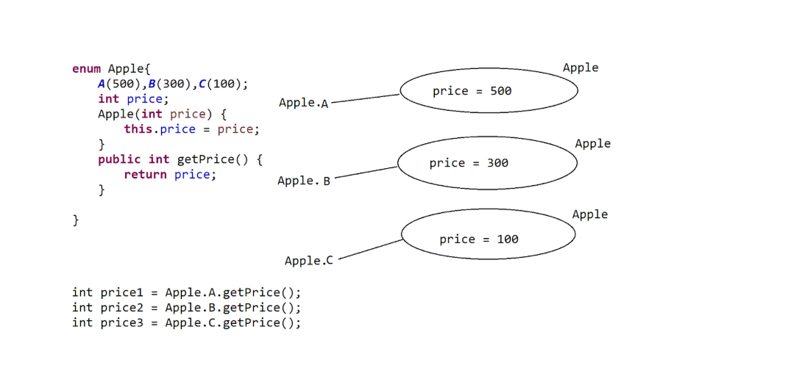

main() method in JAVA
- In java applications we need a main() method to provide application logic and to execute that provided application logic by JVM automatically
- To define starting point and ending point to the application execution we need main() method
- main() method is not a predefined method and it is not a user defined method , it is a conventional method with the fixed prototype and with the user defined implementation, it is a minimum method for every java application to write and manage the application logic , it must be provided by the developers automatically when they want to prepare java applications.
- The main intention of declaring main() method as public is to bring main() method scope to the JVM to access main() method by JVM.
- In Java applications, the main() method must be accessed by JVM in order to start application execution, here JVM was prepared in such a way that to access main() method by using class name, as per the internal implementation of JVM , we must declare main() as static method , because in java applications only static methods are accessed by using class name.
- In Java applications, we must provide the complete application logic inside the main() method, that is, we have to start application logic at starting point of the main() method and we have to end application logic at ending point of the main() method , because Main Thread will start application execution at starting point of the main() method and It will terminate application execution at ending point of the main().
- it is possible to provide more than one main() method in a single java application, but in multiple classes. In this case, which class name we provided along with the “java” command that class provided main() method will be executed.
- it is possible to overload main() method in java applications, but it is not possible to override main() method in java applications, because in java applications static method overloading is possible , but static method overriding is not possible. In the above context, if we provide more than one main() method with the same name and with a different parameter list then JVM will access only the main() method which has a String[] parameter.
Syntax
public static void main(String[] args){
—------
—-----
—------
}

Relationships in Java
Day 74

